SIMATS ENGINEERING (SAVEETHA SCHOOL OF ENGINEERING)
Department of Computer Science and Engineering
CO2 ASSESSMENT TOOL 2 – Architecture Design Assignment
Course Code: | CSA10 / CSA1063 | Course Title: | Software Engineering
CO Assessed: | CO2 | Assessment: | Assessment Tool 2 – Architecture Design Assignment
Weightage: | 20% | Total Marks: | 25
Student Name: | S. Roshni | Reg. No.: | 192525185
Date: | 26-10-2026 | Duration: | 60 minutes

Code of Conduct

I __S.Roshni(192525185)________________________ (Name / Reg No) certify that this submission is my original work and that I have adhered to the guidelines specified for this assessment. I understand that any violation of academic integrity rules will result in disciplinary action.
Signature of the Student: __S.Roshni_______________________
Assigned Problem Statement (No. 35): Distributed Online Collaboration Platform for Large Student Projects

ARCHITECTURE DESIGN REPORT

1. Analysis of System Requirements

1.1 System Objectives
Large student projects involve many teams working in parallel on requirements, design, coding, testing, documentation and presentations. Poor coordination causes duplicated work, merge conflicts, missed deadlines and inconsistent documentation. The platform is therefore intended to give one coordinated, auditable workspace. Its objectives are to:
- Manage project teams, tasks, milestones and responsibilities.
- Support collaborative requirements and documentation.
- Integrate Git-based version control with code reviews (pull requests).
- Provide automated testing and CI/CD for every contribution.
- Track project progress and risks through live dashboards.
- Provide containerized, reproducible development environments.
- Maintain complete project history and tamper-evident audit trails.

1.2 Actors
Students/developers, team leads/project managers, faculty/mentors (reviewers and evaluators), system administrators, and external systems (SSO/LDAP, e-mail/Slack gateways, container registry, Git clients and webhooks).
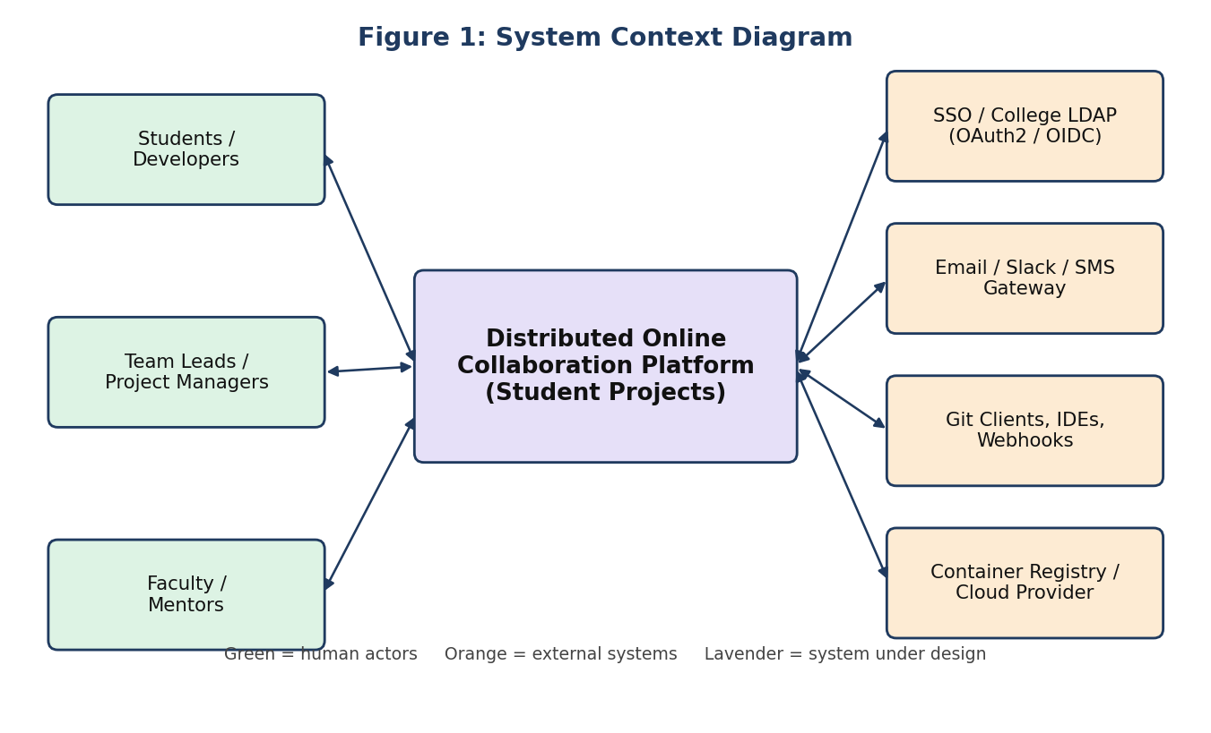
Figure 1: System Context Diagram

1.3 Functional Requirements
ID | Module | Requirement
FR1 | User & Role Management | Register/login via college SSO; assign roles (Student, Team Lead, Reviewer, Faculty, Admin); role-based access control per project.
FR2 | Project & Team Management | Create projects, teams, milestones, sprints and responsibilities; assign members.
FR3 | Issue / Task Management | Create, assign, prioritise, label and track tasks, bugs and requirements; link them to commits and pull requests.
FR4 | Version Control | Host Git repositories; branching, pull requests, protected branches, merge-conflict detection, code review and approvals.
FR5 | Collaborative Documentation | Shared requirement specifications, design documents and wiki with version history.
FR6 | Automated Testing & CI/CD | Trigger build, unit/integration tests, static analysis and deployment on every push or pull request; publish reports.
FR7 | Containerized Dev Environments | Provision reproducible, isolated containers per user or team on demand.
FR8 | Dashboards & Risk Tracking | Show progress, burn-down charts, contribution metrics, overdue tasks and risk register.
FR9 | Notifications | Alert users about reviews, build failures, deadlines and mentions.
FR10 | Audit & History | Record every significant action immutably (who, what, when) and allow audit reports.

1.4 Non-Functional Requirements
Attribute | Requirement
Scalability | Support hundreds of concurrent teams and thousands of users, with spikes near deadlines and demonstration days.
Performance | API response < 500 ms for 95% of requests; dashboard load < 3 s; CI pipeline start < 30 s.
Availability | 99.9% uptime, especially near submission deadlines; no single point of failure.
Reliability | No loss of committed code; automatic retry of failed jobs; backups and disaster recovery (RPO ≤ 15 min).
Security | SSO/OAuth2, RBAC, TLS everywhere, encrypted data at rest, sandboxed containers, secret management.
Maintainability | Modular, independently deployable components; clear APIs; automated tests; central logging.
Interoperability | Standard Git protocol, REST/Webhook APIs, OIDC, OCI-compliant container images.
Auditability | Append-only, tamper-evident history of all actions.

1.5 Key Quality Attributes Driving the Architecture
From the above, the attributes that most strongly shape the architecture are scalability (variable load, many parallel CI jobs), security (multi-tenant student code with different roles), availability (deadline-driven usage), maintainability (several teams evolving different features) and auditability. Performance and reliability are supported by asynchronous processing of long-running work such as builds and tests.

2. Selection of Software Architecture
Selected style: Hybrid architecture – Microservices Architecture combined with Event-Driven Architecture, fronted by an API Gateway, with a Layered (Controller–Service–Repository) structure inside each service, deployed on containers (Kubernetes).

2.1 Justification
Requirement / Need | How the selected architecture satisfies it
Independent, varied workloads (Git hosting, CI jobs, dashboards, issue tracking) | Each capability is a separate microservice that can be scaled independently; CI runners can scale out heavily without affecting issue tracking.
Long-running tasks (builds, tests, environment provisioning) | Event-driven messaging decouples the request from the work; users are not blocked and jobs are queued, retried and parallelised.
Real-time project visibility and audit | Services publish events (push.created, build.finished, issue.updated); dashboard, notification and audit services subscribe without tight coupling.
Many teams working on different modules | Small services with clear APIs let teams develop, test and release independently, reducing merge conflicts and coordination overhead.
Security and RBAC | Central API Gateway and Auth service enforce authentication and authorisation; each service owns its data.
Containerized environments & CI/CD | Microservices are naturally container-based, so the platform itself follows the same DevOps practices it teaches.
Future growth | New services (e.g. plagiarism check, AI code review) can be added by subscribing to events without changing existing services.

2.2 Alternatives Considered
Style | Advantages | Why not chosen alone
Layered Monolith | Simple to build and deploy | Scales as one unit; CI load would slow the whole platform; harder for many teams to change safely.
MVC / Client-Server | Easy for small web applications | Does not address distributed processing, asynchronous jobs or independent scaling.
Serverless | Pay-per-use, auto-scaling | Long builds, Git hosting and persistent dev containers fit poorly; cold starts; vendor lock-in.
SOA with ESB | Reusable enterprise services | Heavy central bus becomes a bottleneck and is more complex than needed.
Microservices + Event-Driven (chosen) | Independent scaling, fault isolation, loose coupling, extensible | Higher operational complexity – mitigated with Kubernetes, API gateway and centralized monitoring.

3. Software Architecture Diagram
Figure 2 shows the overall structure: clients, edge, API gateway, microservices, event bus, data stores, platform infrastructure and external systems. Solid arrows indicate synchronous REST/gRPC calls and dashed arrows indicate asynchronous publish/subscribe events.
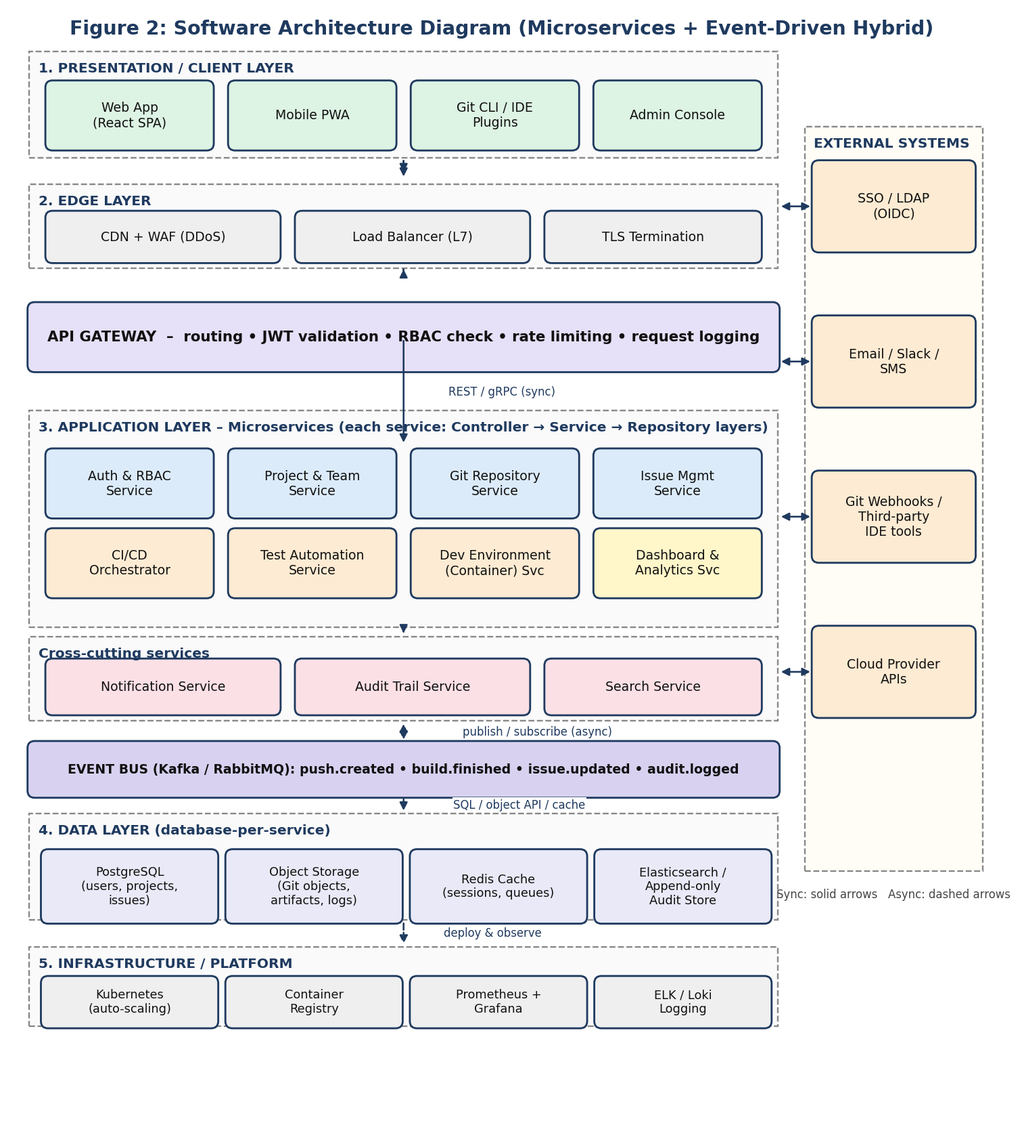
Figure 2: Software Architecture Diagram
Notation: rectangles denote components/services, dashed boxes denote layers or logical groups, cylinders-style boxes in the data layer denote stores, and labelled arrows denote the communication mechanism (REST/gRPC, pub/sub, SQL/object API).

4. Components and Their Interactions

4.1 Component Responsibilities
Component | Purpose and responsibilities | Technology (example)
Web App / Mobile PWA | User interface for tasks, repositories, reviews, documents and dashboards. | React, PWA
Git CLI / IDE Plugins | Developers push/pull code using standard Git over HTTPS/SSH. | Git, VS Code
CDN + WAF + Load Balancer | Caches static content, filters malicious traffic, distributes requests, terminates TLS. | NGINX, CDN
API Gateway | Single entry point: routing, JWT validation, RBAC check, rate limiting, request logging. | Kong / Spring Cloud Gateway
Auth & RBAC Service | Authentication via SSO (OIDC), token issue, roles and permissions per project. | Keycloak, OAuth2
Project & Team Service | Projects, teams, milestones, sprints, responsibilities. | Spring Boot / Node.js
Git Repository Service | Hosts repositories, branches, pull requests, code review, merge-conflict checks, protected branches. | Gitea/GitLab core
Issue Management Service | Tasks, requirements, bugs, labels, priorities, links to commits/PRs, risk register. | REST service
CI/CD Orchestrator | Receives events, creates pipelines, schedules build/test/deploy jobs, tracks status. | Jenkins / GitLab CI
Test Automation Service | Runs unit, integration, static-analysis and coverage jobs in sandboxed containers; stores reports. | JUnit, PyTest, SonarQube
Dev Environment Service | Provisions on-demand containerized workspaces with pre-configured tools. | Docker, Kubernetes
Dashboard & Analytics Service | Aggregates events into progress, burn-down, contribution and risk views. | Grafana-style service
Notification Service | Sends e-mail, Slack and in-app alerts. | SMTP, Webhooks
Audit Trail Service | Stores immutable records of all actions for evidence and compliance. | Append-only store
Search Service | Full-text search across code, issues and documents. | Elasticsearch
Event Bus | Reliable asynchronous messaging between services. | Kafka / RabbitMQ
Data Stores | PostgreSQL (transactional), Object storage (Git objects, artifacts, logs), Redis (cache, sessions, queues), Elasticsearch (search, audit). | —
Infrastructure | Kubernetes orchestration with auto-scaling, container registry, monitoring and central logging. | K8s, Prometheus, ELK

4.2 Communication and Data Exchange
- Synchronous requests: Clients call the API Gateway over HTTPS (REST/JSON) with a JWT; the gateway validates the token and permissions, then forwards the call to the target service via REST/gRPC.
- Asynchronous events: Services publish domain events (JSON messages) to the event bus; interested services subscribe. This decouples producers from consumers and allows retry and replay.
- Data ownership: Each service owns its database (database-per-service); other services obtain data only through APIs or events, never by direct database access.
- Storage: Large files (repositories, build artifacts, logs) are kept in object storage; Redis caches sessions and frequently read data.
- External integration: Git clients use HTTPS/SSH to the repository service; external tools use webhooks and REST APIs.

4.3 Overall System Workflow
The typical workflow of a code contribution is illustrated in Figure 3:
- The developer logs in through SSO, opens a task in the Issue service, and works in a containerized dev environment.
- The developer pushes a branch and opens a pull request through the API Gateway, which verifies the token and role.
- The Git Repository Service stores the code, checks for merge conflicts and publishes a push.created event.
- The CI/CD Orchestrator consumes the event and starts a pipeline; the Test Automation Service runs tests and static analysis in sandboxed containers.
- On success, the image is pushed to the registry and a preview deployment is created; on failure, a report is returned to the developer.
- Reviewers (peers/faculty) review and approve the pull request; the code is merged and the linked issue is closed automatically.
- The Dashboard service updates progress and risk indicators, the Notification service alerts the team, and the Audit service records every step.
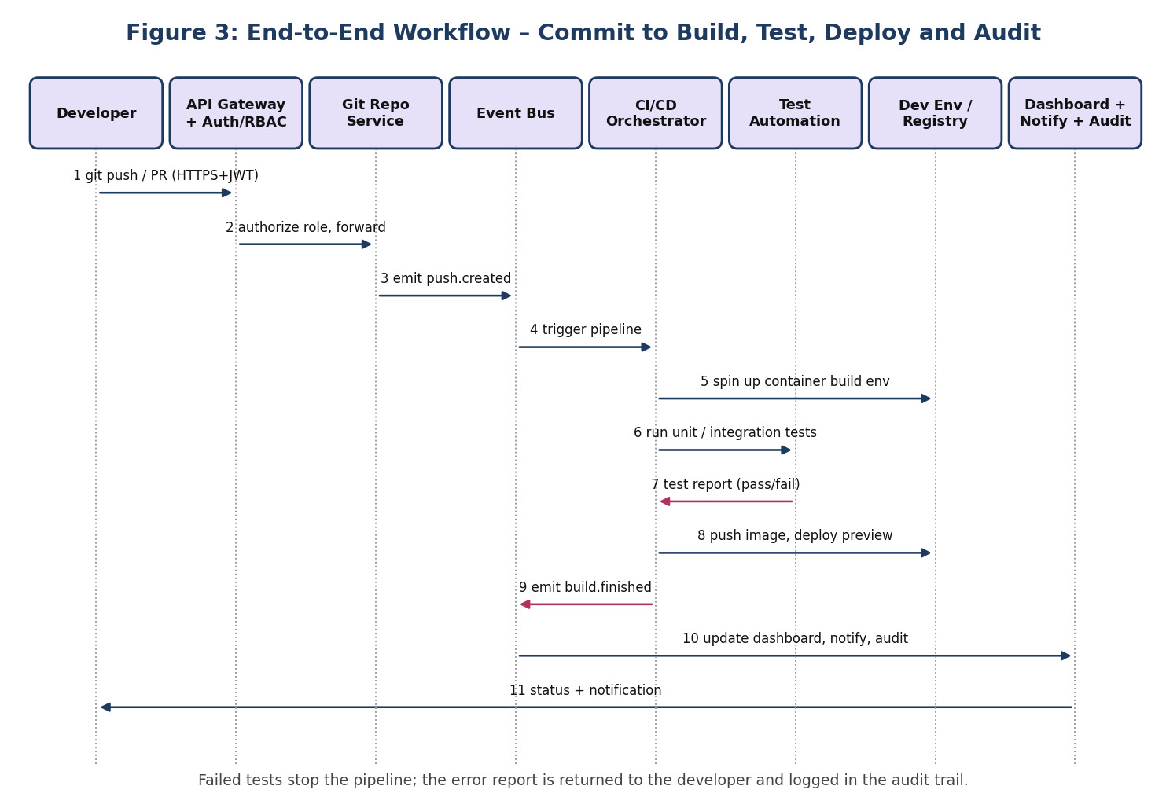
Figure 3: End-to-End Workflow (Sequence of Interactions)

5. Quality Attributes
Attribute | How the architecture addresses it
Scalability | Stateless services run as multiple replicas with Kubernetes Horizontal Pod Autoscaler; CI/test runners scale out independently during deadline peaks; Kafka partitions distribute load; read replicas and Redis caching reduce database pressure; database-per-service allows independent data scaling.
Security | SSO (OIDC/OAuth2) with short-lived JWTs; RBAC enforced at gateway and again in each service (defence in depth); TLS in transit and encryption at rest; sandboxed, resource-limited, non-root containers for student code; secrets in a vault; WAF and rate limiting; protected branches; dependency and image scanning; immutable audit log.
Performance | CDN for static assets; Redis caching; asynchronous processing of builds and notifications; database indexing and search engine for fast queries; pre-built base images for fast environment start-up; pagination and compression of API responses.
Reliability | Message persistence and retry with dead-letter queues; idempotent consumers; health checks and automatic pod restart; circuit breakers and timeouts between services; replicated storage and scheduled backups; failed jobs do not affect other services (fault isolation).
Maintainability | Small, loosely coupled services with versioned APIs; layered code inside each service; separate CI/CD per service; automated unit and integration tests; centralized logging, metrics and tracing for quick diagnosis; Infrastructure-as-Code and containers for reproducible deployment.
Availability | Multi-zone deployment with redundant gateway and service replicas; load balancer health checks; database primary–replica failover; rolling and blue-green deployments with zero downtime; graceful degradation (e.g. dashboards may lag but Git push continues).

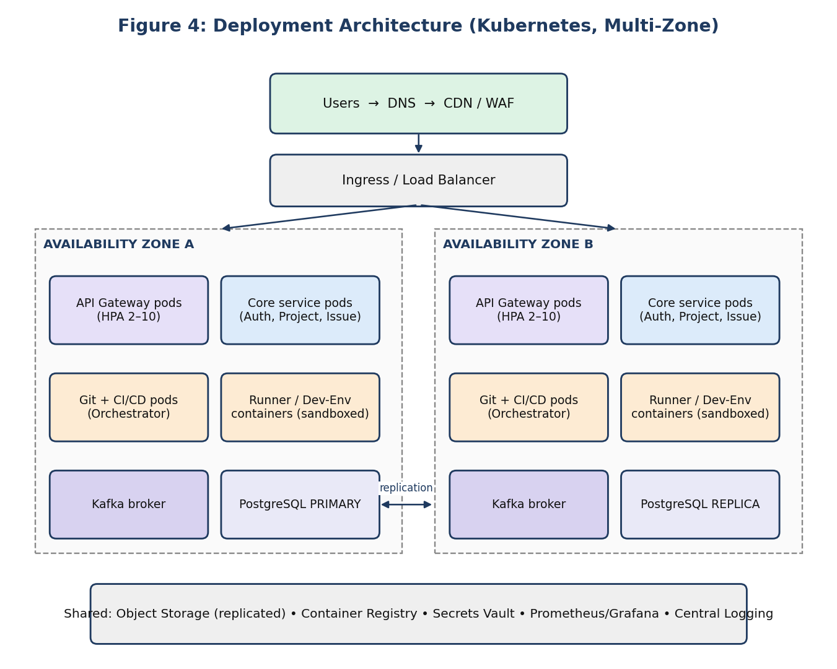
Figure 4: Deployment Architecture (supports Availability and Scalability)

6. Justification of Architectural Decisions

6.1 Rationale for Key Choices
- Microservices: distinct capabilities with very different load and release cycles (Git, CI, issues, dashboards) are best isolated so each can scale and evolve independently.
- Event-driven communication: build, test and notification work is naturally asynchronous; events give loose coupling, replay and a natural source for dashboards and audit trails.
- API Gateway: a single secured entry point simplifies authentication, RBAC, throttling and monitoring.
- Database-per-service with polyglot storage: each service uses the best-suited store (relational for transactions, object storage for Git data, search engine for queries, append-only store for audit).
- Containers and Kubernetes: provide isolation for untrusted student code, reproducible environments, and automated scaling and recovery.
- Layered design within services: separates controllers, business logic and persistence, improving testability.

6.2 Trade-offs Considered
Trade-off | Cost | Mitigation
Operational complexity vs. flexibility | More services to deploy and monitor than a monolith | Kubernetes, Helm, CI/CD per service, centralized monitoring; start with coarse-grained services.
Eventual consistency vs. loose coupling | Dashboard and search data may lag by seconds | Acceptable for reporting; strong consistency kept for Git and issue transactions.
Network latency vs. modularity | Inter-service calls add latency | Caching, gRPC, async events, and avoiding chatty calls.
Security isolation vs. cost | Sandboxed containers consume more resources | Resource quotas, auto-scaling and idle-environment shutdown.
Build vs. reuse | Building Git/CI from scratch is costly | Integrate proven open-source components (Gitea/GitLab, Jenkins, Keycloak) behind the platform's APIs.

6.3 Support for Future Enhancements, Integration and Long-term Maintainability
- Future enhancements: New capabilities such as plagiarism detection, AI-assisted code review, automated grading or learning-analytics can be added as new services subscribing to existing events without modifying current services.
- System integration: Standard protocols (Git, REST, OIDC, webhooks, OCI images) allow integration with LMS platforms (Moodle), cloud providers, IDEs, Slack/Teams and third-party tools.
- Long-term maintainability: Versioned APIs, independent deployments, automated tests, Infrastructure-as-Code and centralized observability let different student or admin teams update components safely; technology of one service can be replaced without affecting others.
- Growth: Horizontal scaling, multi-zone deployment and a pluggable event bus allow the platform to grow from one department to the whole institution.

7. Conclusion
The hybrid Microservices and Event-Driven architecture, supported by an API Gateway, containerized infrastructure and CI/CD, best meets the needs of a Distributed Online Collaboration Platform for Large Student Projects. It improves collaboration and visibility, reduces duplicated work and merge conflicts, enforces quality through automated testing and reviews, and preserves project evidence through audit trails, while remaining scalable, secure, available and maintainable.
Rubrics for Calculation
Evaluation Criteria | Excellent (4 Marks) | Good (3 Marks) | Satisfactory (2 Marks) | Needs Improvement (1 Mark)
System Requirement Analysis (30%) | Thoroughly analyzes the problem statement, accurately identifies functional and non-functional requirements, and clearly explains quality attributes influencing the architecture. | Analyzes most requirements with minor omissions or limited explanation. | Identifies only basic requirements with partial analysis. | Requirement analysis is incomplete, inaccurate, or lacks clarity.
Selection of Software Architecture (25%) | Selects the most appropriate architectural style with strong technical justification aligned to system requirements. | Selects a suitable architecture with reasonable justification. | Architecture is partially suitable with limited justification. | Inappropriate architecture selected or justification is missing.
Architecture Diagram and Component Design (20%) | Produces a clear, complete, and well-structured architecture diagram with all major components, interfaces, and interactions accurately represented. | Diagram is mostly complete with minor omissions or notation issues. | Diagram includes only essential components and lacks sufficient detail. | Diagram is incomplete, unclear, or technically incorrect.
Component Interaction and Quality Attribute Analysis (15%) | Clearly explains component responsibilities, interactions, and thoroughly discusses scalability, security, performance, reliability, maintainability, and availability. | Explains most components and quality attributes with minor gaps. | Provides limited explanation of interactions and addresses only some quality attributes. | Component interactions and quality attributes are poorly explained or missing.
Architectural Justification and Technical Presentation (10%) | Provides strong justification for architectural decisions, discusses trade-offs and future enhancements, and presents a well-organized, professional report. | Provides adequate justification with minor gaps; report is well organized. | Limited justification with minimal discussion of trade-offs or future scope; report needs improvement. | Justification is weak or absent; report lacks organization and technical clarity.

Criteria | Mark
System Requirement Analysis (30%) | /5
Selection of Software Architecture (25%) | /5
Architecture Diagram and Component Design (20%) | /5
Component Interaction and Quality Attribute Analysis (15%) | /5
Architectural Justification and Technical Presentation (10%) | /5
TOTAL | /25

